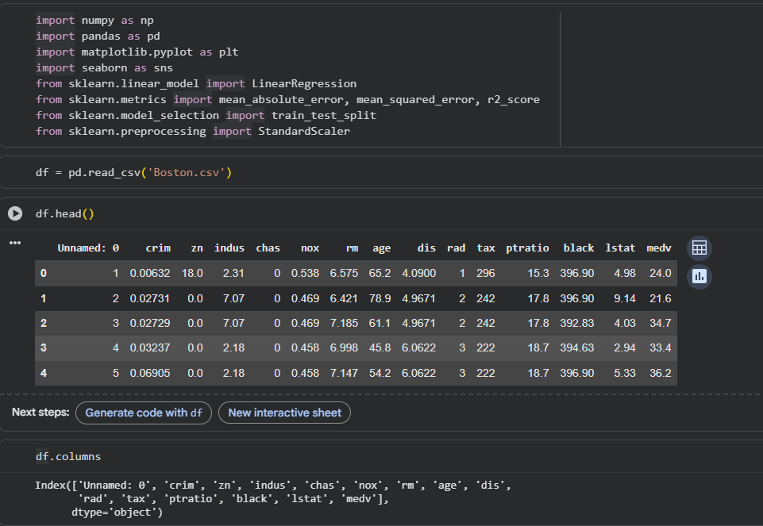
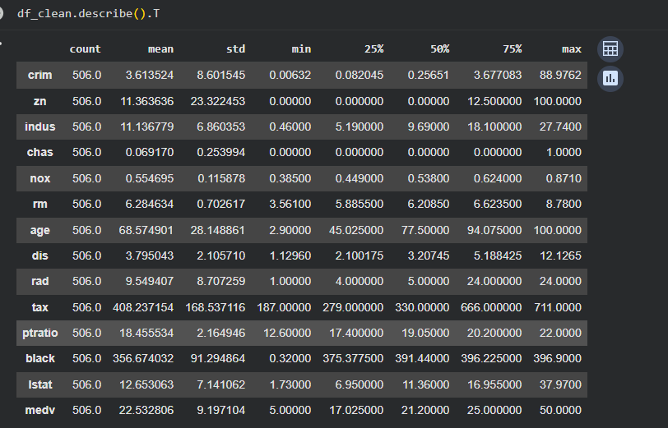
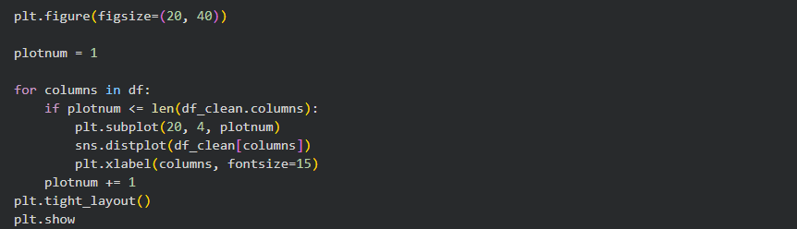
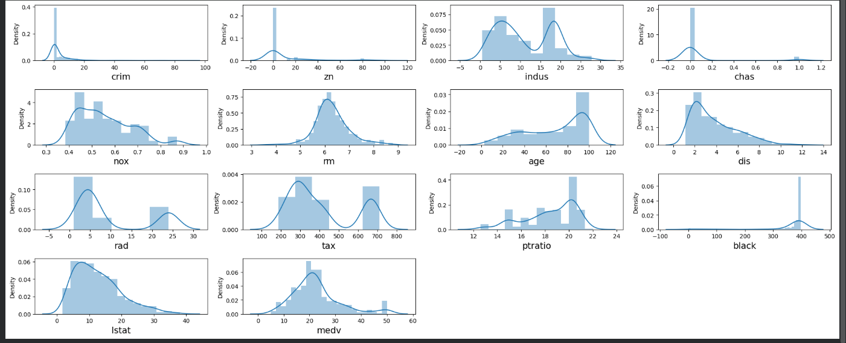

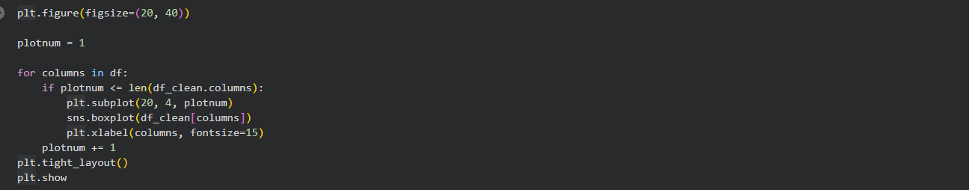
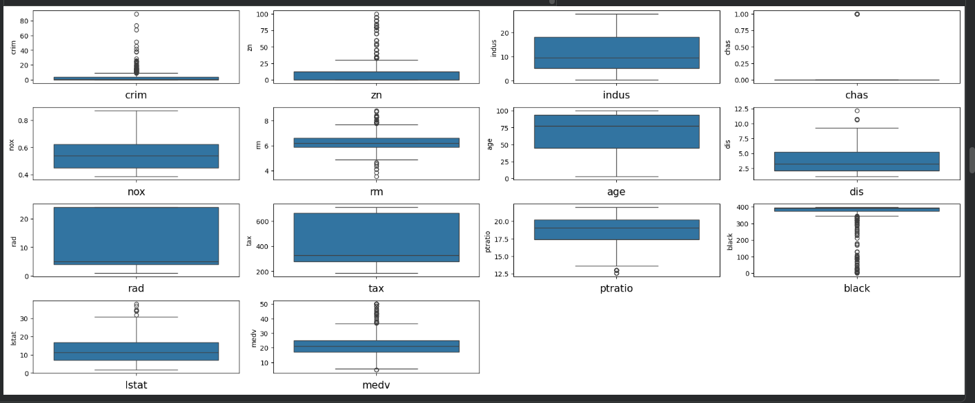
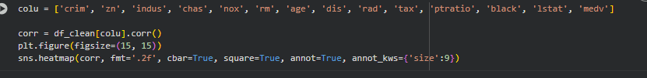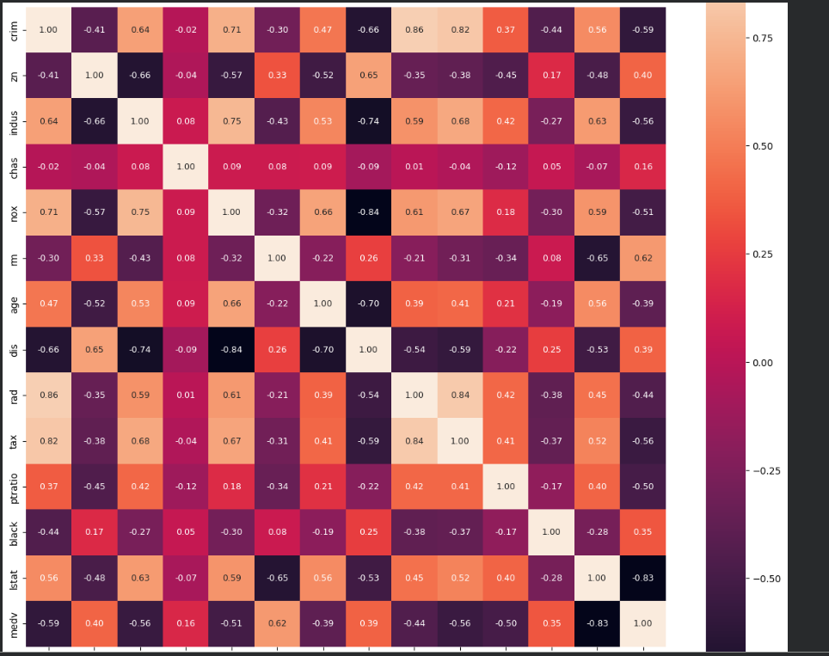
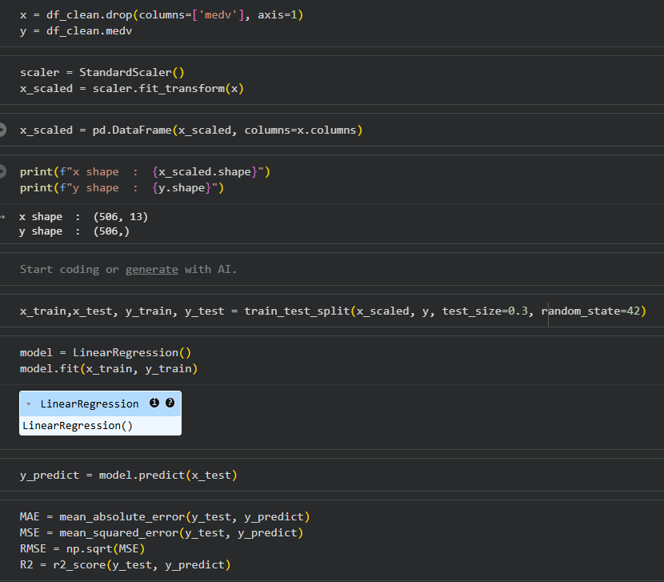
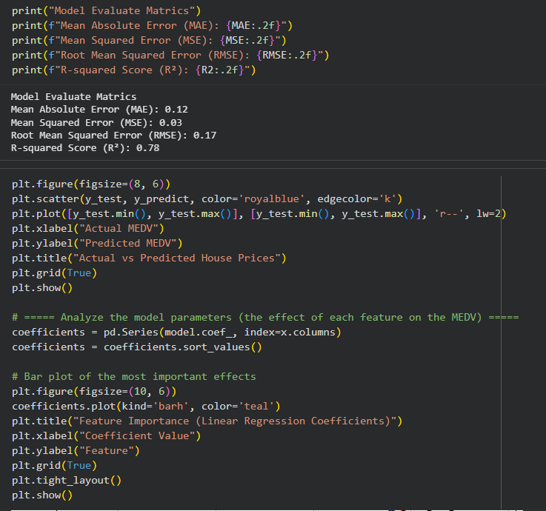
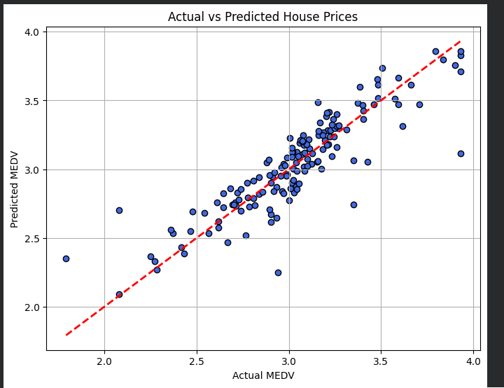
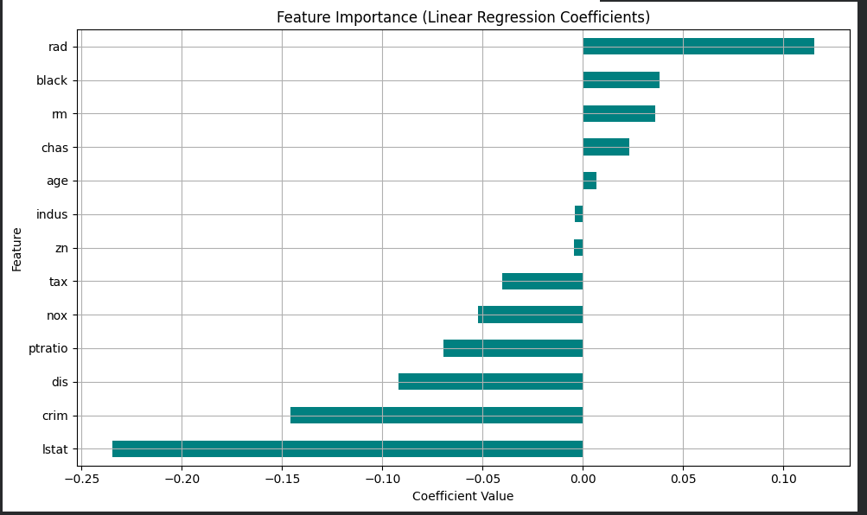

1. Data Loading and Initial Inspection
Libraries Imported: Essential libraries like numpy, pandas, matplotlib, seaborn, sklearn. StandardScaler were imported for data manipulation, visualization, and machine learning.
Data Loading: The Boston.csv file was loaded into a pandas DataFrame named df.
Initial View: df.head() was used to display the first few rows, and df.columns showed all column names, revealing an 'Unnamed: 0' column.
Data Information: df.info() provided a summary of the DataFrame, including data types and non-null counts for each column.
2. Data Cleaning
Dropping Unnecessary Column: The 'Unnamed: 0' column, which appeared to be an artifact of the CSV export, was dropped using df.drop('Unnamed: 0', axis=1, inplace=True).
Duplicate Check: df.duplicated().sum() was used to check for duplicate rows, and no duplicates were found.
Missing Values: df.isnull().sum() confirmed that there were no missing values in the dataset initially.
3. Exploratory Data Analysis (EDA)
Descriptive Statistics: df_clean.describe().T provided summary statistics (mean, std, min, max, quartiles) for all numerical columns, giving insights into their distributions.
Distribution Plots: Histograms (using sns.distplot) were generated for all features to visualize their distributions. This helped identify skewed features and potential outliers.
Box Plots: Box plots (using sns.boxplot) were created for all features to visually identify outliers more clearly.
Outlier Detection & Handling: The Interquartile Range (IQR) method was applied to numerical columns to detect outliers. The code iterated through columns, calculated IQR, and identified outliers. While the code for removing outliers (df_clean = df_clean[(df_clean[col] >= lower_bound) | (df_clean[col] <= upper_bound)]) was present, it seems to have significantly reduced the DataFrame size potentially by filtering rows based on a problematic | (OR) condition instead of & (AND) to keep non-outliers. This might have led to an unexpected data loss or transformation.
Pair Plot: sns.pairplot(df_clean) was used to visualize pairwise relationships between all variables, which is useful for understanding correlations and dependencies.
Correlation Heatmap: A correlation heatmap was generated using sns.heatmap to show the correlation matrix between all features and the target variable (medv). This helps identify features that are strongly correlated with the target or with each other.
4. Feature Engineering
Log Transformation: To address skewness observed in the distribution plots, all columns in df_clean were transformed using np.log1p(). This transformation is often applied to positively skewed data to make it more Gaussian-like, which can improve the performance of linear models.
5. Model Preparation
Feature and Target Split: The dataset was split into features (x) and the target variable (y, which is medv).
Feature Scaling: StandardScaler was used to standardize the features (x_scaled). Standardization scales features to have a mean of 0 and a standard deviation of 1, which is crucial for many machine learning algorithms, including Linear Regression, to prevent features with larger scales from dominating the learning process.
Train-Test Split: The scaled features (x_scaled) and target (y) were divided into training and testing sets using train_test_split with a test_size of 30% and random_state=42 for reproducibility.
6. Model Training and Evaluation
Model Initialization & Training: A LinearRegression model was initialized and then trained (model.fit) using the training data (x_train, y_train).
Prediction: The trained model was used to make predictions (y_predict) on the test set (x_test).
Evaluation Metrics: The model's performance was evaluated using standard regression metrics:
Mean Absolute Error (MAE): 0.12
Mean Squared Error (MSE): 0.03
Root Mean Squared Error (RMSE): 0.17
R-squared Score (R²): 0.78
Visualization of Predictions: A scatter plot of actual vs. predicted medv values was generated, along with a red dashed line representing perfect predictions, to visually assess model performance.
Feature Importance: A bar plot of the model coefficients was created to show the 'importance' or impact of each feature on the medv prediction. The coefficients, sorted, indicate which features have the strongest positive or negative influence on the target variable.

